FORM 19.

Regulation 18 (1)

Application for a Licence to Manufacture Drugs

Physical address of premises _______________________________________

P. O. Box No. _______________ Tel. ______________ Fax _____________

Name of applicant ___________________________________________

Qualifications (pharmaceutical) ___________________________________

(Other) ______________________________________________________

Is the application made for —

a partnership ____________________________________________________

a company _____________________________________________________

If applying on behalf of a company—

Physical address of registered office ________________________________

P. O. Box No. _______________ Tel. ______________ Fax _____________

Name of managing director ________________________________________

If applying on behalf of a company or partnership give the following information for all partners or directors—

Name__________________________________________________________

Address________________________________________________________

Qualifications___________________________________________________

Has the applicant or any partner or director been convicted, of any offence involving the wrongful or illegal dealing in or supply or possession of drugs

within or outside Uganda? Yes/No

If “yes”, give details ____________________________________________

Has any previous application by the applicant, or any partner or director, for a licence to operate any type of business under the Act been refused or

cancelled? Yes/No

1232

If “yes”, give details ______________________________________________

Does the applicant or any partner or director currently hold a licence to operate any type of business under the Act, including the business of selling class C drugs, at any other premises? Yes/No

If “yes”, give details ______________________________________________

Name and registration number of the pharmacist in charge of the manufacturing processes _________________________________________

Name and registration number of pharmacist or name of the chemist to be in charge of quality control and assurance _______________________________

Names, qualifications and registration number of the other pharmacists employed and names of the other or chemists employed _________________

I certify that the above information is correct and apply for a licence to manufacture drugs at the above-named premises.

______________________________ _____________________

Signature of applicant Date

For Authority use:

Suitability of premises certificated checked Yes/No

____________________________________________________ (Signature)

Applicant’s information checked and verified Yes/No

_____________________________________________________ (Signature)

Licence to manufacture drugs approved/not approved

If not approved, give reasons _______________________________________.

_____________________________ ___________________________

For Authority Date

FORM 20

Regulations 19 (4)

Application for Assessment for Compliance with Good

Manufacturing Practice Guidelines

(A separate application form should be filled for each site)

- Particulars of applicant/licence holder

Name_____________________________________________________

Physical Address____________________________________________

Country__ _______________Telephone_________________________

Fax ________________E-mail_________________________________

- Particulars of site to be inspected

Name of manufacturing site________________________________

Physical address (if different from number 1)

Country _____________________Tel___________________________

Fax_ ________________E-mail:_______________________________

- Contact person at manufacturing site

Name of contact person_______________________________________

Tel: _________________________Fax:_________________________

E-mail:___________________________________________________

- Type of drugs manufactured (Tick where applicable)

(a) Human only (b) veterinary only (c) human & veterinary

- Inspection type (Please tick where applicable)

  - First inspection

  - Routine re- inspection (previous inspection date…………………)

  - Re-inspection after failure ……………………………………....

  - Other (please specify)……………………………………………

1234

- Lines to be inspected
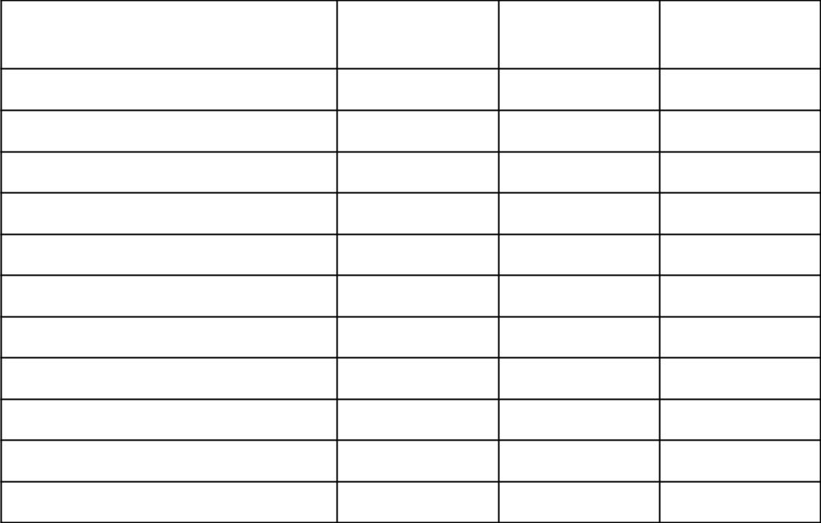

Tick where
Dosage form *category **activities applicable

Tablets

Capsules

Injections (SVP)#

Injections (LVP) #

Oral liquids

Powders for oral suspension

Creams/Ointments/lotions

Others (specify)

*Category means, Beta lactam (Penicillin), Beta lactam (Cephalosporins), Non-beta lactam, Biologicals, Vaccines, Hormones, Cytotoxic products.

**Activity means any step in the manufacturing process that is conducted at the site such as the complete manufacture of dosage form, primary or secondary packaging, quality control and warehousing.

#
Small Volume Parenterals (SVP) refers to packs of 100ml or less and Large Volume Parenterals (LVP) are packs of more than 100ml.

- Registration of drugs
Has the applicant applied for registration of the drugs?
No Yes

If yes, list the drugs. (Attach a separate sheet if needed) …………….

- Inspection dates

In order to schedule an inspection, the applicant should indicate an approximate date from which the applicant may be ready for the inspection. If this date changes after the application is submitted, the applicant shall notify the Authority as soon as possible.

1235

Approximate date when the facility is to ready for inspection ……/…../……

(For re-inspections, not more than three months after expiry of GMP validity) The actual date of the audit will be advised to the applicant by the Authority.

Site master file

It is requested that the applicant encloses with this application form a copy of
the site master file (not more than 25 pages).
Enclosed -Yes  No 

I hereby certify that the above information is correct and apply for Good Manufacturing Practice inspection of the above-named site or sites.

Signature of applicant………………………. Date……………………………

Name of applicant……………………………………………………………..

FORM 21

Regulation 19 (5)

Certificate of Compliance with Good Manufacturing

Practice Guidelines

The National Drug Policy and Authority Act, Cap 206

Certificate No. ……………………

This is to certify that the drug manufacturing facility:

Name of facility _________________________________________________

Physical address of facility _________________________________________

Licence number of the manufacturer ________________________________

Has been inspected by the Authority for compliance with the Good Manufacturing Practice Guidelines.

On the basis of the inspection carried out ____________ [dd/mm/yyyy], it is certified that the facility indicated on this certificate complies with Good Manufacturing Practice for dosage forms listed in Table 1 below.

Table 1: Approved lines
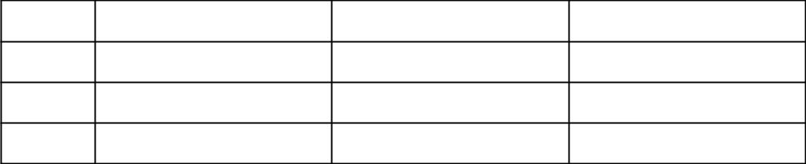

No. | Dosage form | Category | Activities

1.

2.

3.

The responsibility for the quality of the individual batches of the drugs manufactured through this process lies with the manufacturer.

This certificate remains valid until ________________ [dd/mm/yyyy]. It becomes invalid if the activities or the categories certified change or if the facility is no longer considered to be in compliance with GMP.

……………………………………….

For the Authority

